Information for Exhibitors

Bradford West Gwillimbury Public Library and Cultural Centre offers exhibit space free of charge to local artists, collectors, cultural groups, and organizations and invites anyone to apply for consideration to exhibit on our walls, our public television, in our display cases, or other locations within our space. Application is not restricted to area residents, although decision-making will be filtered through our exhibition priorities. All applications will be considered. Selected persons exhibit during the year following acceptance of their application and signing of the Loan Agreement and Waiver of Liability. On our walls, the Library exhibits two-dimensional works, including paintings, drawings, mixed media, textile art, prints and photographs. In our Display Cases, the Library exhibits three-dimensional works, collections, and educational content. For any other inquiry, please contact the Library before filling out an application.

EXHIBITION SPACES:
- Main floor hanging area: (approximate measurements)
East Wall Entrance
East Wall behind express computers: 5.79 m X 1.0668 m OR 19’ X 3 ½’
- Second floor hanging areas:
East Wall adjacent to elevator: 8.8392 m X 2.4384m OR 29’ X 8’
North Wall adjacent to Boardroom: 7.0104 m X 2.4384 m OR 23’ X 8’
Our hanging system consists of cables suspended from overhead rails, with height-adjustable hooks on each cable. We have 105 cables and 105 hooks, each of which can support 20.5 Kgs. Each frame must be securely prepared with a hanging wire on back.
- Zima Room hanging space for special exhibits
I.E. Studio Art Tour, a weekend show or an afternoon event to display works without leaving them unattended.
- The Main Floor Display Case
Situated across from Borrower Services Desk, 3.35mX 1.22mX .45m OR 11’ long X 4’ high X 1 1/2’ deep
There are 12 – 36cm X 79cm OR 14” X 31” glass shelves, suspended by cables, which create 4 display levels divided into 4 separate sections. The height of the glass shelves can be adjusted, though they generally range in height from 25cm OR 10” to 36cm OR 14”. The locked glass display case can accommodate small sculptures and 3-dimensional works.
- The Local History Display Case
Situated on the 2nd floor north wall. 5.64m X 1.68m X 36cm OR 18 1/2’ long X 5 ½’ high X 14” deep
There are 24 – 36cm X 86cm OR 14” X 34” glass shelves, suspended by cables, which create 4 display levels divided into 6 separate sections. The height of the glass shelves can be adjusted. Preference will be given to displays of a historical nature

Guidelines for Exhibitors
- The exhibitor is responsible for mantling and dismantling the exhibit on the agreed upon dates.
- The Library will assist exhibitors as much as possible throughout the exhibiting process.
- The exhibitor is responsible for creating small title cards for each work/item, which can be placed on the wall or display case using sticky tack (Tape is prohibited from being used on the walls).
- The exhibitor is responsible for creating a biography and /or artist/exhibit statement, and is welcome to include contact information in this statement;
- Exhibitor is responsible for announcements: I.E. contacting local media, e-mail announcements, posters, providing description and images for Library website.
- There are no restrictions on selling exhibited work. All transactions are between the seller and the purchaser. Items sold may not be removed before end of show, without prior arrangements.
- Safety cannot be guaranteed. Each exhibitor must sign a waiver to exclude the Library from liability. We suggest that exhibitors carry their own insurance coverage.
- The Library reserves the right to cancel the booking and to dismantle if necessary.
- Alongside an application, all exhibitors are asked to include the following supporting material: I) a biography and/or statement pertaining to the display, and II) photographs/digital images/website where images of display work are available.
For more information contact David Di Giovanni, Manager of Cultural Services, at
905-775-3328 ext. 6123 or e-mail ddigiovanni@bradford.library.on.ca.

Photos of Exhibit Spaces
East Wall behind Computer | 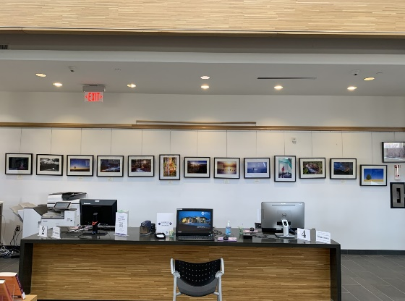 | Zima Room | 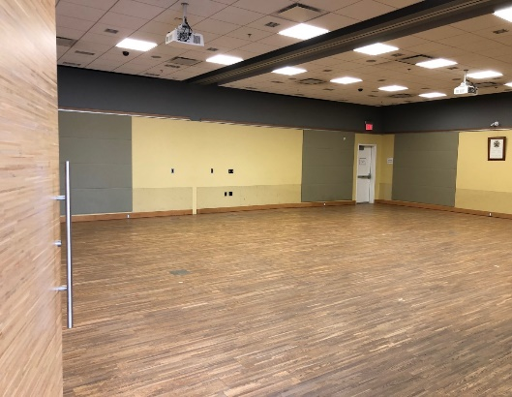
East Entrance Walls (Café) | 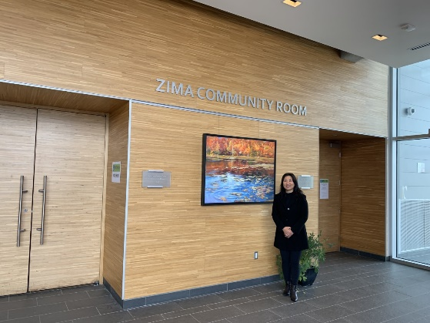 | East Entrance Wall (Atrium) | 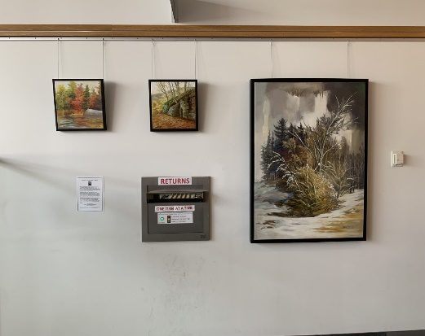
Second Floor North Wall | 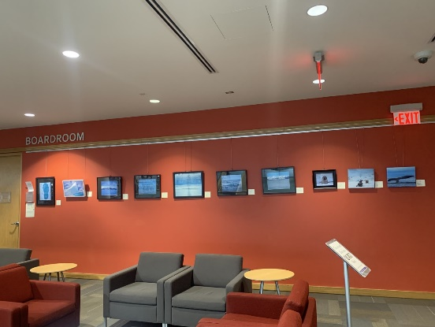 | Second Floor East Wall | 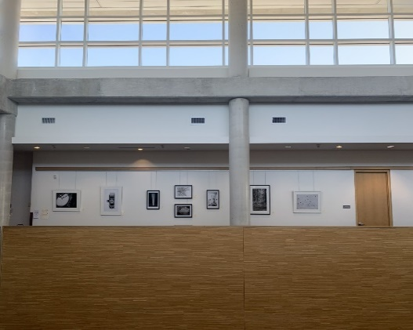
Main Floor Display Case | 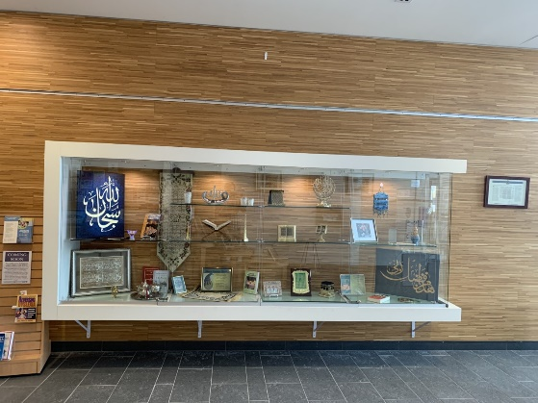 | Local History Display Case | 